In Mongo DB the structure is like:

Database > Collection > Document

Since this is a NoSQL database, there is no need of schema, since there are no joins, the data is presented in JSON like structure with {key: value} pairs. This is a kind of advantage because we can have different attributes in the same documents for different fields, which is not possible in SQL databases.

Explanation: In SQL databases you have to define the columns and its types and after that whatever record you store, you have to give the values for all the columns which make the attributes same i.e. each record will have same column-based attributes.

In Mongo DB, you can have different “key” for different records, like this:  
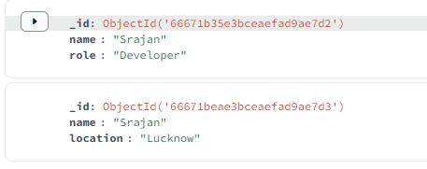

1 Two data from Same Document with different keys

*Displaying all databases*

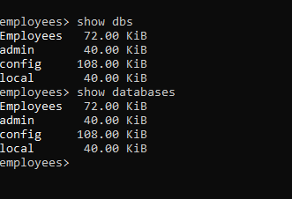

To learn more about CRUD operations: <https://www.mongodb.com/docs/manual/crud/>

* Mongo DB is case-sensitive with respect to the name of collection and documents you use in the commands.

*Read Operation through .find() Method*

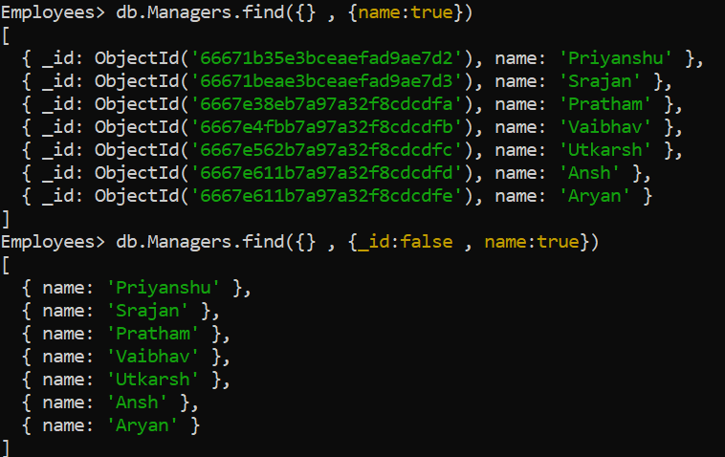

.find({query condition} , {projection})

*Update Operation*

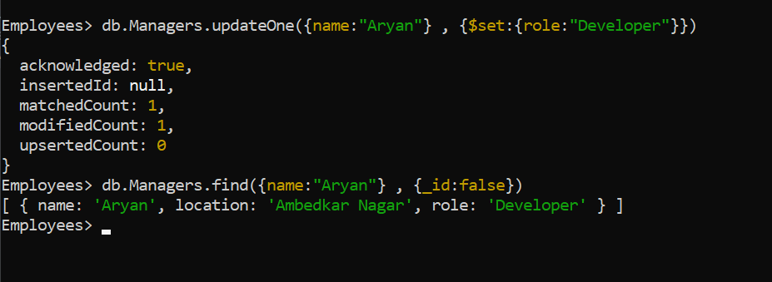

Here ‘Aryan’ was not assigned a role earlier, so updated using the updateOne() function.

**4. Update Operators**

Mongo DB provides several update operators that you can use in the <update> document to specify how the fields should be updated. Here are some commonly used update operators:

* $set: Sets the value of a field.
* $unset: Removes a field.
* $inc: Increments the value of a field by a specified amount.
* $mul: Multiplies the value of a field by a specified amount.
* $rename: Renames a field.
* $min: Updates the field if the specified value is less than the current value.
* $max: Updates the field if the specified value is greater than the current value.
* $currentDate: Sets the value of a field to the current date.